**NATIONAL UNIVERSITY OF SCIENCES AND TECHNOLOGY**



**Fundamentals of Programming**

**Lab manua 9**

**Course Instructor:** Dr Khawaja Fahad Iqbal

**Lab Instructor:** Muhammad Affan

**Student Name:** MANAHIL SHAHZAD

**CMS ID:** 466695

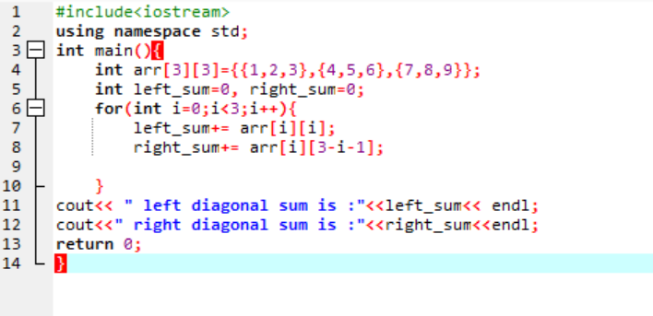**TASK 1:**

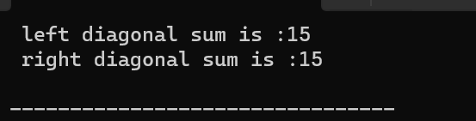

**TASK 2:**

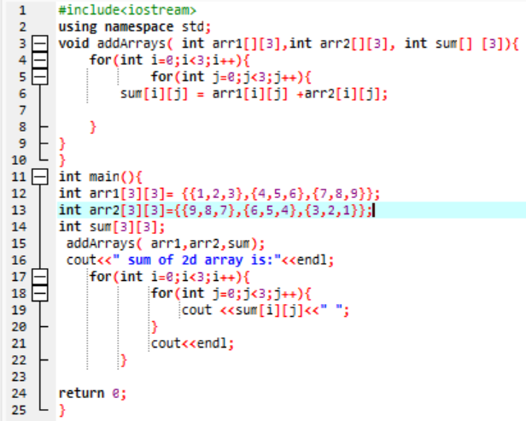

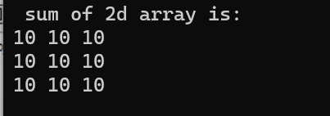

**TASK 3:**

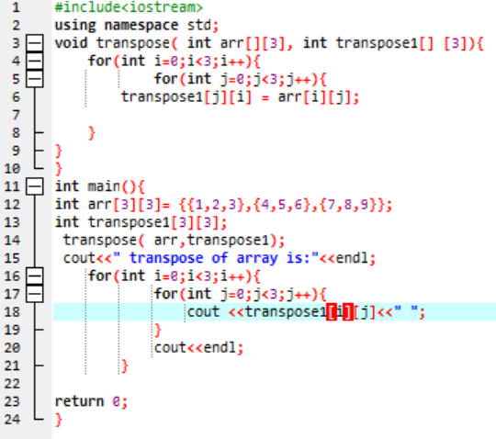

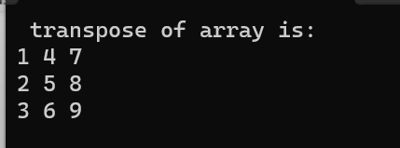

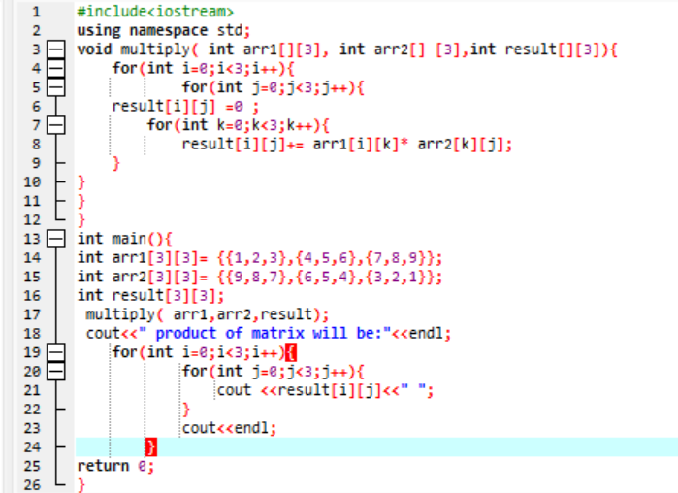TASK 4:

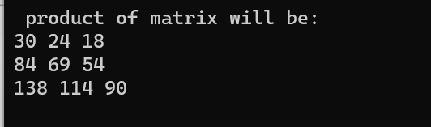

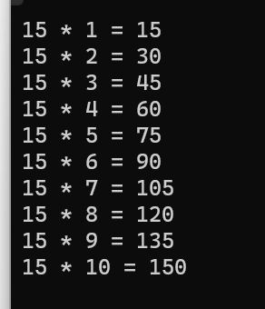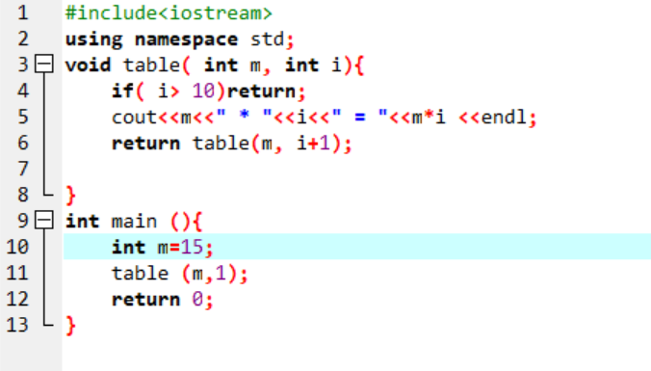**TASK5:**